**Assignment 3**

**BA 830 Spring 2021**

**Due Date: April 5, Noon ET**

The Tweetment Effect on the Tweeted (50 points)

Case Study: Stubhub Price Salience Experiment (50 Points)

How long did this problem set take you in hours? How did you find the level of difficulty?

**Instructions: Please use assignment3_notebook.Rmd to do this assignment. You may also download these and do the problem set on your laptop.**

**IMPORTANT NOTE: IF YOU SPEND MORE THAN 5 MINUTES TRYING TO UNDERSTAND WHAT A QUESTION IS ASKING, LET ME KNOW!!!**

REMINDER: Please label your answers when you submit the assignment on Gradescope. I will take points off if you don’t.

Before you submit the pdf, please make sure that the text is readable. For some of you, the written answer spilled over the right side of the screen. To prevent this from happening, make sure to write your answer in the Markdown, not in the code chunk.

### The Tweetment Effect on the Tweeted (50 points)

For this assignment, we will practice using regression by analyzing a field experiment conducted on Twitter. This is based on the paper [“Tweetment Effects on the Tweeted: Experimentally Reducing Racist Harassment”](https://link.springer.com/article/10.1007%2Fs11109-016-9373-5#Sec25) by Kevin Munger. **You do not have to read it.**

What you need to know about the experiment is the following. Professor Munger identified accounts on Twitter that posted racist tweets. He then randomized these accounts to a control group or one of four possible treatment arms. The accounts in the treatment arms received responses to their racist tweets of the following form:

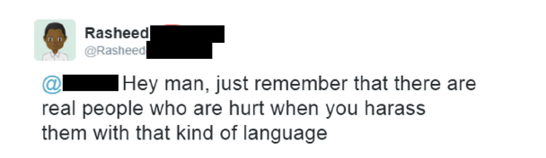

The treatment arms varied by the characteristics of the account that sent the above message. The research question is: “Did the treatment reduce racist behavior?”

|  |  |
| --- | --- |
| ***Variable Definitions for tweetment_effect.csv*** | |
| *treatment_arm* | *There are four treatments (1 - 4) and a control (0).* |
| *any_treatment* | *Did the subject receive any of the treatments? (1 = yes, 0 = no)* |
| *anonymity* | *Was the twitter account anonymous?*  *Quote from the paper: “To create an anonymity score, I examined several aspects of each subject’s profile: whether they had a profile picture of themselvesFootnote2 and whether a given name was present in their username or handle. I used these to create a categorical anonymity score that ranged from 2 (most anonymous) to 0 (least anonymous).” Measured prior to experiment.* |
| *log.followers* | *Log of the number of followers of account*  *Measured prior to experiment.* |
| *racism.scores.pre.2mon* | *Measure of how racist the account was in the 2 months before experiment.* |
| *racism.scores.post.2mon* | *Measure of how racist the account was in the 2 months after experiment.* |
| *racism.scores.post.1mon* | *Measure of how racist the account was in the 1 month after experiment.* |

1. Of the above variables, please identify which may be ‘good’ control variables in a regression where the outcome is ‘racism.scores.post.2mon’ and the regressor is ‘any_treatment’?

Note: By good control variables, I mean those which do not prevent a causal interpretation of the coefficient on treatment.

1. Run a regression and a t.test of ‘racism.scores.post.2mon’ on ‘any_treatment’. What do we learn from this regression about the effect of the treatment? Please explain in words in addition to just returning the number.
2. Perform a randomization / balance check on this dataset for all of the variables identified in a). Hint: we can do this by comparing the pre-treatment outcomes between the treatment and control group. If there are significant differences, then there may be a problem with the experiment.
3. Add the variables from a) as controls into the regression from b). What happens to our estimate of the effect of the treatment and it’s standard error? Why does this happen in words?
4. BONUS: we would like to know whether treatment arm 2 or treatment arm 3 is statistically significantly better at reducing racist behavior. Perform a t.test or regression and test for the null hypothesis that treatment arm 2 has the same effect as treatment arm 3.

### 

### Case Study: Stubhub Price Salience Experiment (50 Points)

This case is based on [“Price Salience and Product Choice”](http://faculty.haas.berkeley.edu/stadelis/AIP.pdf) by Blake et al.

Please read **only** pages 1 - 3 (ending at ‘Reassuringly, the results are broadly consistent with our findings from the 2015 experiment, indicating that this concern is not first-order in our setting.’) and the pasted text below.  
  
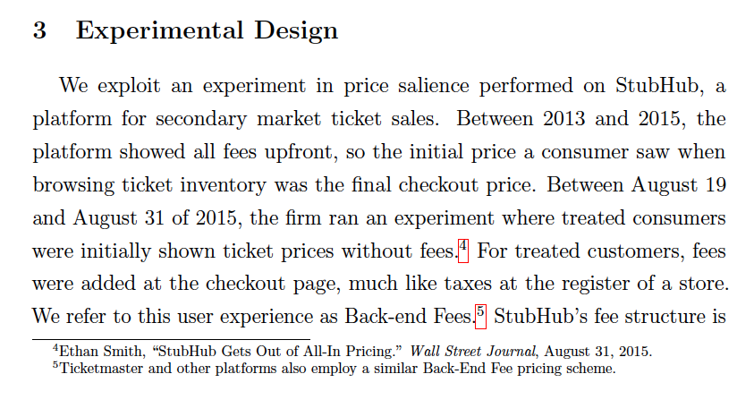

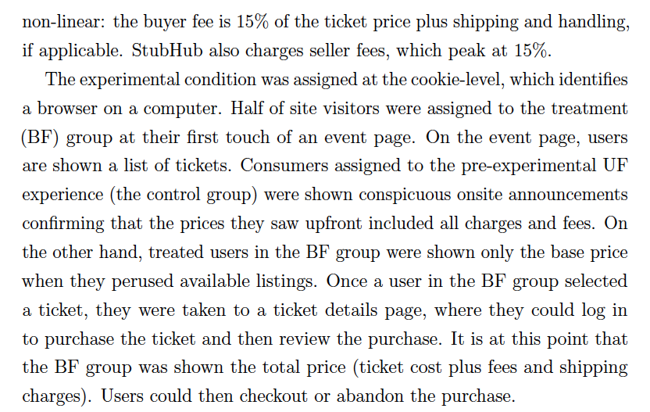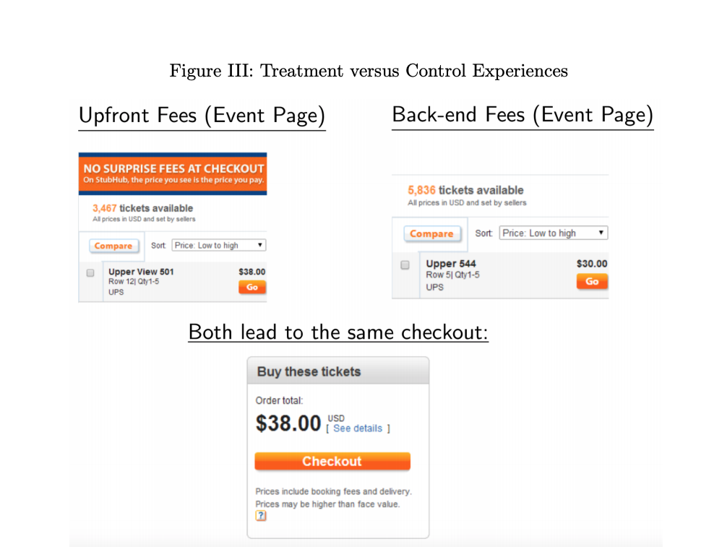

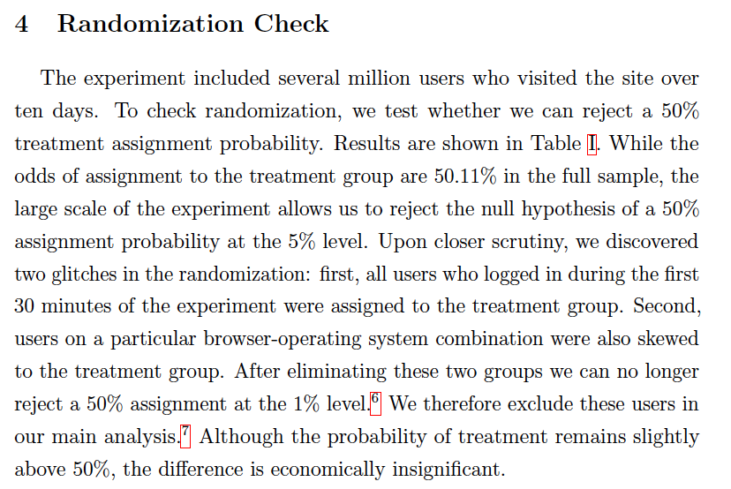

**The authors also tested whether the treatment and control groups were similar on characteristics observed prior to the treatment assignment. They say:**

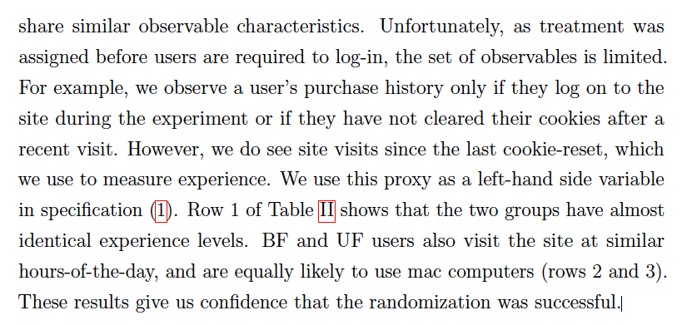

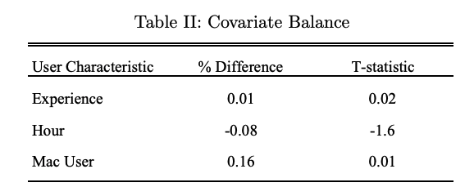

**This table displays the treatment effects in percent terms, as well as the standard errors in percent terms, which are displayed in parentheses.**

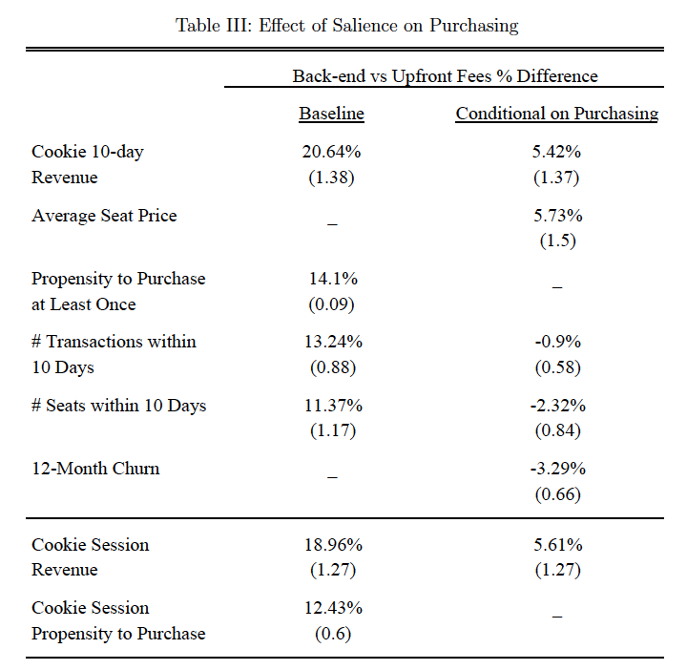

1. Describe the treatment in the first experiment and the unit of randomization. What share was randomized to the treatment?   
   (This refers to the experiment conducted in August 2015, the first experiment described in the introduction of the paper.)
2. Table II displays a randomization / balance check. A randomization check is a regression where the dependent variable occurs before the experiment. The treatment should have no effect if the experiment was done properly. Suggest a variable not used by the authors that would be appropriate to include in a balance check. *Hint: consider whether your proposed variable is measured before the treatment happens or after the treatment happens.*
3. What is the effect of the treatment on the Propensity to Purchase at least one product? Calculate the 95% confidence interval for this estimate.
4. Suppose the authors randomized by city of the event. Name one benefit that may occur as a result of this randomization strategy and one harm.
5. Suppose that you are the product manager for the monetization team at Stubhub. Based on the evidence presented above, would you launch the treatment to the entire site? The answer should be less than 1 paragraph. It should consist of an answer (Yes, no), and two pieces of evidence relating to that recommendation.

### How long did this problem set take you in hours? How did you find the level of difficulty?